[Astronauts, Spaceship, Universe. Free Stock Video - Pixabay](https://pixabay.com/videos/astronauts-spaceship-universe-91379/)

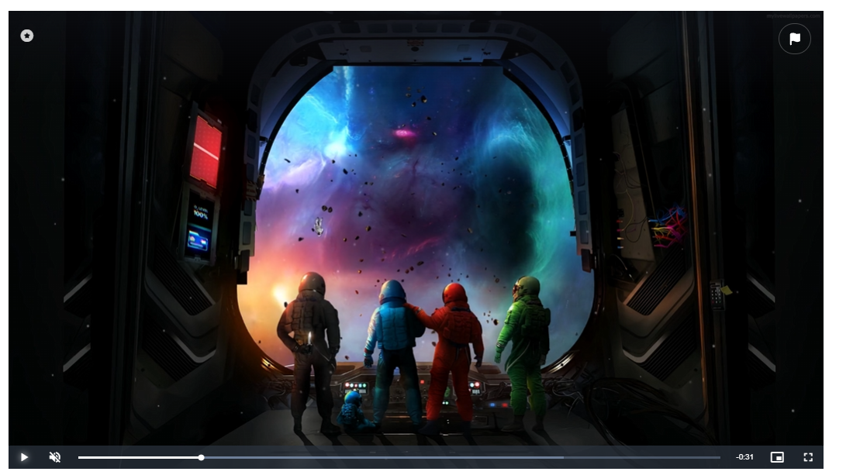

[Astronauts, Planets, Exoplanets. Free Stock Video - Pixabay](https://pixabay.com/videos/astronauts-planets-exoplanets-space-184345/)

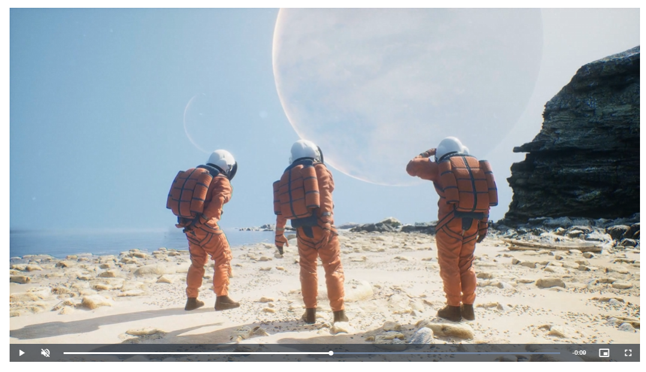

[Cast, Comet, Universe. Free Stock Video - Pixabay](https://pixabay.com/videos/cast-comet-universe-anti-tail-237574/)

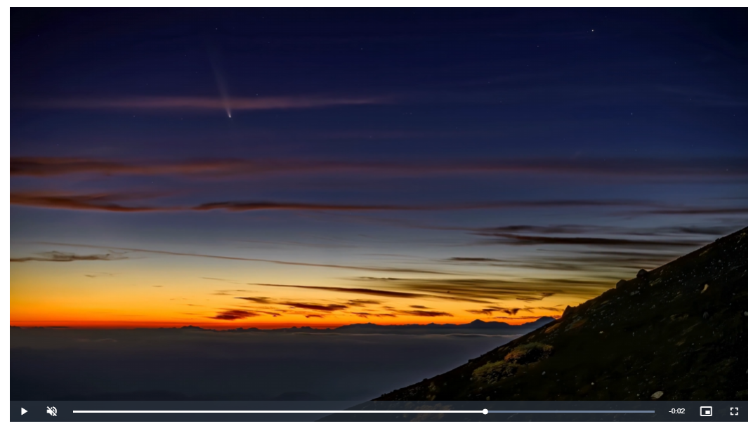

[Planet, Mars, Surface. Free Stock Video - Pixabay](https://pixabay.com/videos/planet-mars-surface-astronauts-186200/)

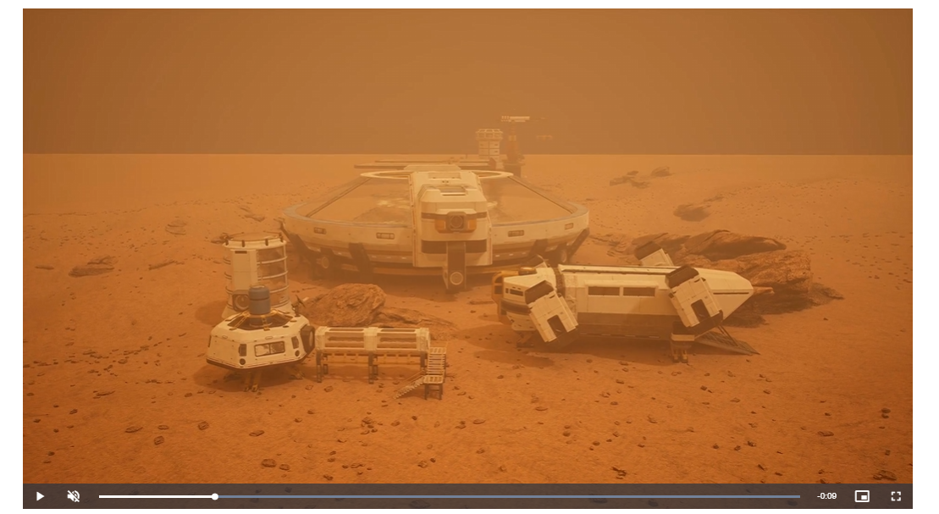

[Planet, Solar System, Space Travel. Free Stock Video - Pixabay](https://pixabay.com/videos/planet-solar-system-space-travel-228976/)

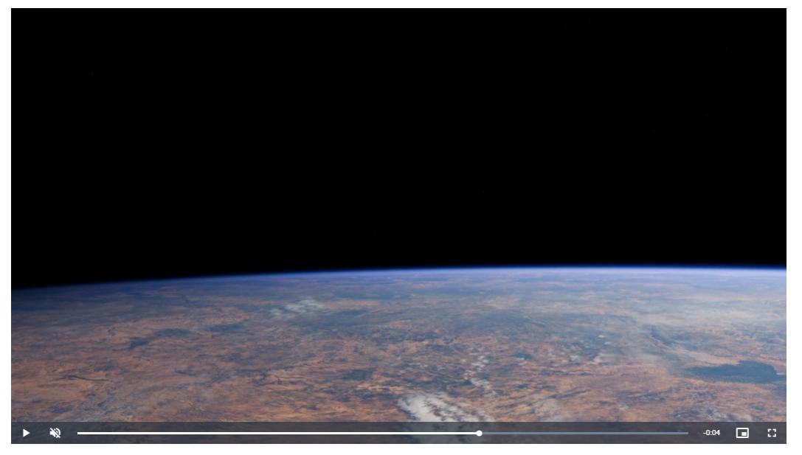

[Network, Loop, Energy. Free Stock Video - Pixabay](https://pixabay.com/videos/network-loop-energy-technology-12716/)

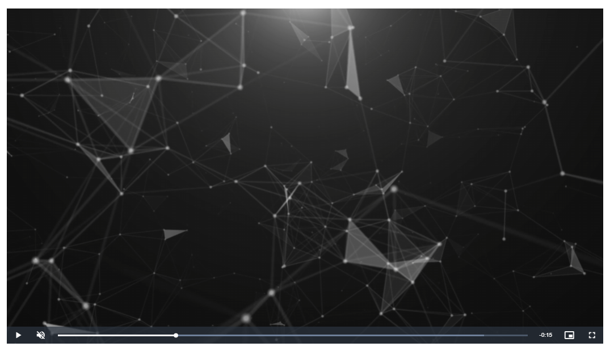

[Plasma Ball, Plasma Lamp, Lamp. Free Stock Video - Pixabay](https://pixabay.com/videos/plasma-ball-plasma-lamp-lamp-11414/)

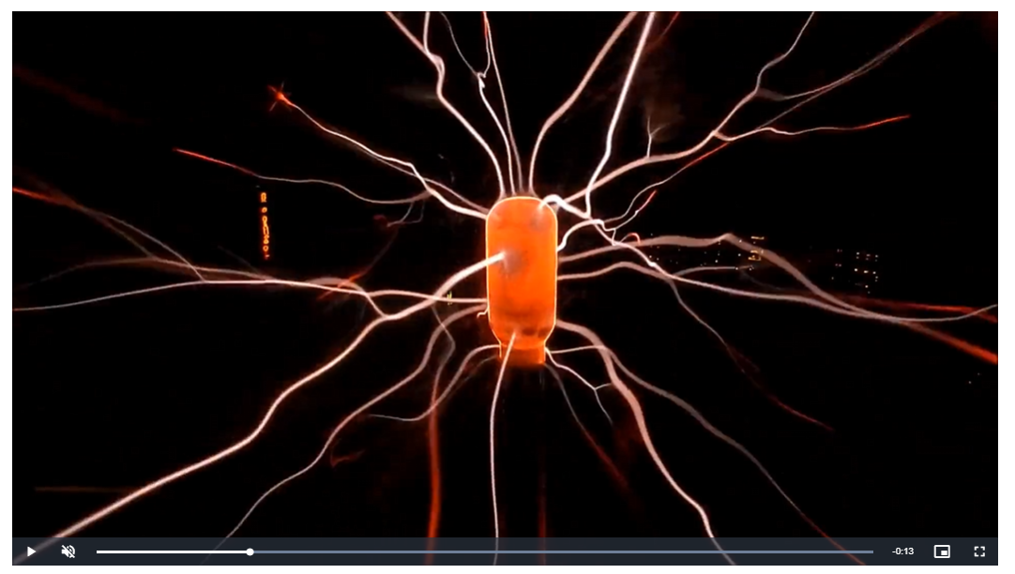

[Astronaut, Galaxy, Universe. Free Stock Video - Pixabay](https://pixabay.com/videos/astronaut-galaxy-universe-earth-261402/)

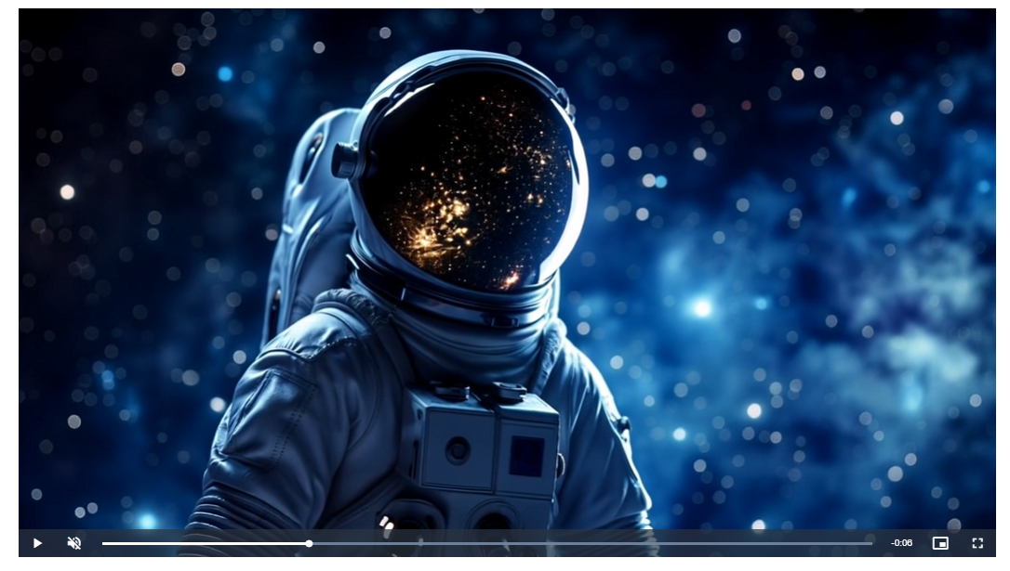

[Astronaut, Space, Universe. Free Stock Video - Pixabay](https://pixabay.com/videos/astronaut-space-universe-rocket-224276/)

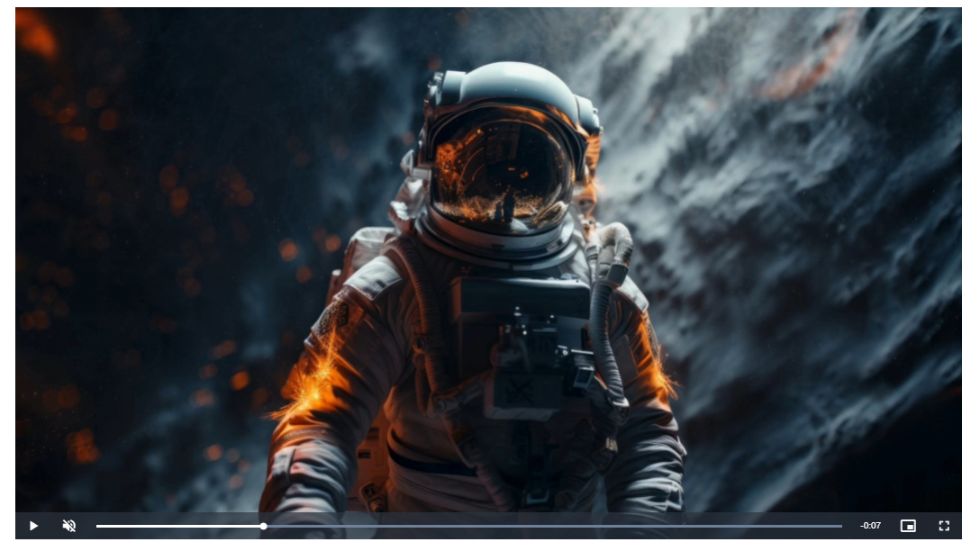

[Ai Generated, Alien, Space. Free Stock Video - Pixabay](https://pixabay.com/videos/ai-generated-alien-space-sci-fi-259337/)

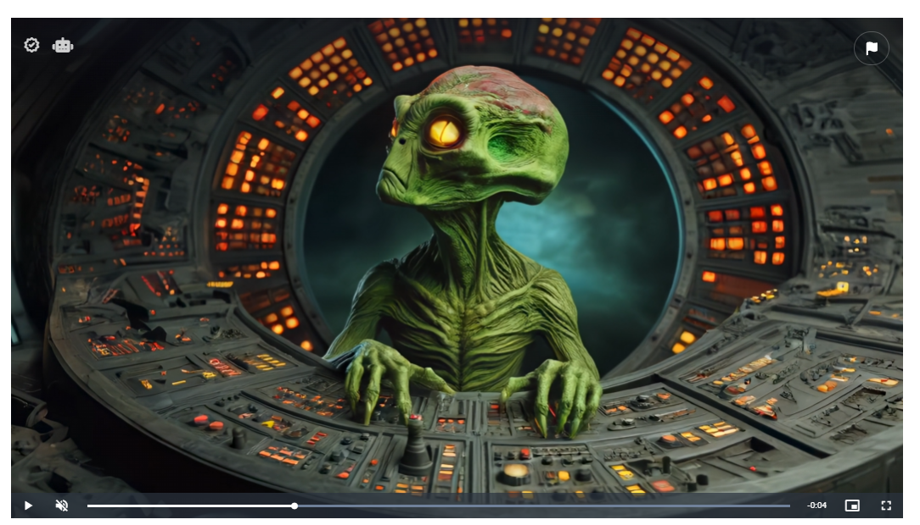

[Astronaut, Hall, Space. Free Stock Video - Pixabay](https://pixabay.com/videos/astronaut-hall-space-science-88140/)

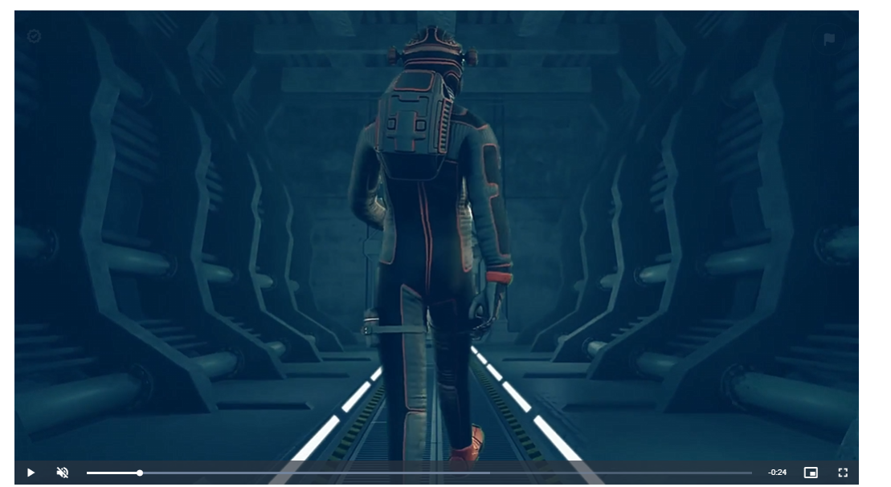

[Students Raising Hands in Class · Free Stock Video](https://www.pexels.com/video/students-raising-hands-in-class-8198505/)

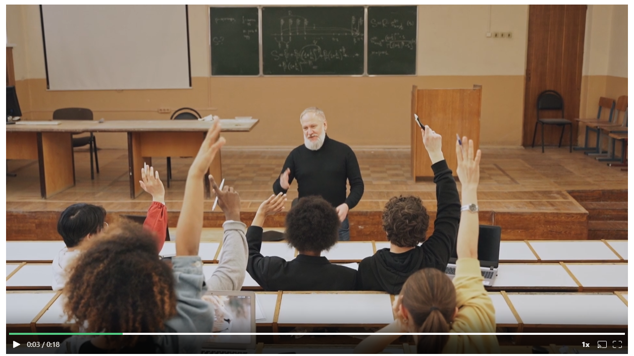

[Astronaut, In A Hurry, Galaxy. Free Stock Video - Pixabay](https://pixabay.com/videos/astronaut-in-a-hurry-galaxy-science-73190/)

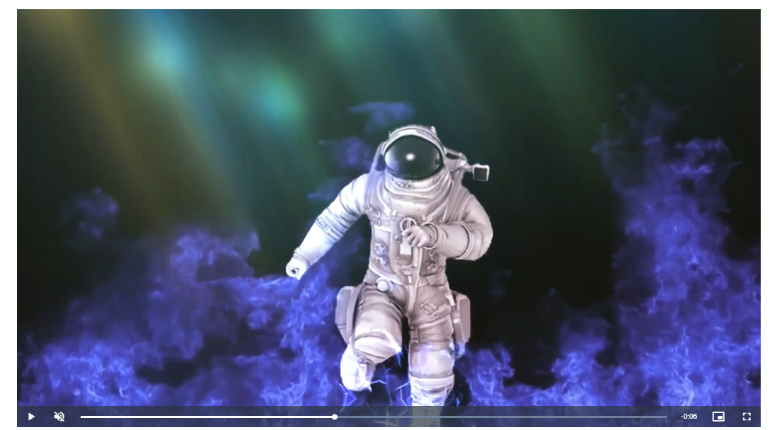

Sounds:

Youtube Audio Library:

Kurt

Between The Spaces - The Soundlings

Argonne - Zachariah Hickman

Can't Be Beat - The Soundings

Capcut

[AI Voice Generator & Text to Speech | ElevenLabs](https://elevenlabs.io/app/sign-in?redirect=/app/speech-synthesis/text-to-speech)

[Alien white space | Royalty-free Music - Pixabay](https://pixabay.com/music/pulses-alien-white-space-166296/)

Images:

Photoshop generative

3D models:

Blender plugin BlenderKit